Student Name
Institution Name

Question 1
Supply is accompanied by demand. The two are intertwined in that you cannot talk of one and leave the other out. Supply basically refers to the quantity of goods and services that producers and providers of services are willing to offer to the general public.
Demand on the other hand refers to the quantity of goods and services which are available for consumers to use or purchase.
Supply curve is a graphical representation of the correlation between the cost of a good or service and the quantity supplied for a given period.
When price of grains increases, demand of grains will decrease. Few consumers will have the ability to purchase them and this is in tandem with the law of demand which says an increase in price of a commodity leads to a decrease in the quantity demanded. On the other hand, demand for grains substitutes like choice beef will start increasing as demand for them will be high hence pushing the supply to the right meaning expansion. This is in line with the law of supply which states that an increase in the price of a commodity leads to an increase in the quantity supplied.
The below table shows supply shifting to the right indicating an increase in supply.

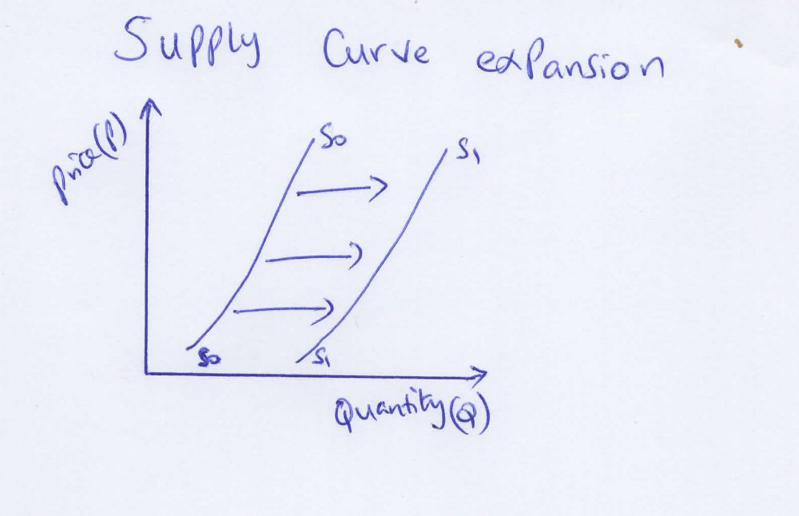

If the situation persists, prices will continue to hike. Many suppliers will tend to sell (supply) more when prices are high as their motive is to increase profits. Assuming consumers are willing to purchase at high prices, they will purchase until supply decreases or shifts to the left meaning contraction in supply.
See the below diagram explaining this.

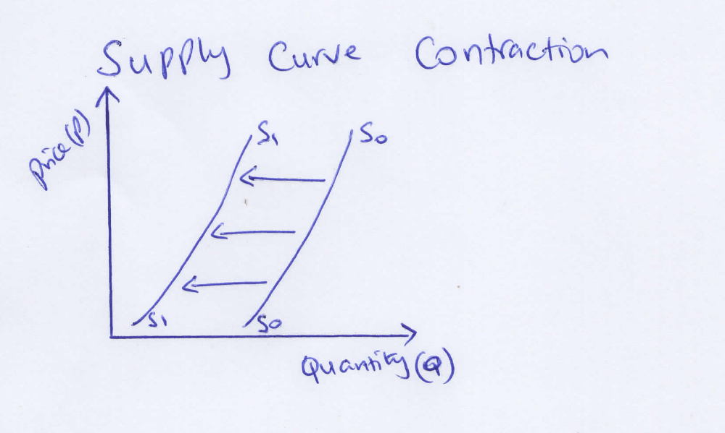

Therefore, the prediction by agriculture department that a shortage in supply will occur is very correct.

Question 2
The owner of the restaurant is interested in maximizing his total revenue. Total revenue is amount earned from selling a quantity of goods and services multiplied by the price of the good or service. He is trying to achieve maximum sales through different options. In such a case, the option yielding the maximum revenue, is optimal one and owner should go by it.

Streak entrée option
Last year, $2 decrease from $15 in streak entrée resulted to sales increasing from 75 to 100 weekly. This means new price was reduced to $13.
Total Revenue (TR) = Price (P) multiplied by Quantity (Q).
Initially, TR= 15*75= $1,125.
After reducing the price to $13, totals sales went up to 100.
Therefore, TR= 13*100= $1,300
Salmon entrée option
Last year, $2.50 decrease from $17 in salmon entrée resulted in increase in sales from 40 to 75 weekly. This means new price was reduced to $14.5.

Total Revenue (TR)= Price (P) multiplied by Quantity (Q).
Initially, TR=17*40= $680
After price reduction to $14.5
TR= 14.5*75= $1,087.5
From the above analysis, the best option is to reduce the streak entrée price by $2 to be sold at a price of $13. This pushes the sales high and yields the maximum revenue. Here the price reduction has a direct relationship with sales recorded meaning that it is more elastic.
Price elasticity measures the correlation between ta change in quantity demanded of a particular good and a change in its price.

Question 3
a) Area of producer surplus after price ceiling
Producer surplus is the difference between the price a firm receives and the price it would be willing to sell it at.
Assuming price ceiling is at 1,
Producer surplus will be triangle F.
The Y-axis forms the base of the triangle and the X-axis forms the height.
Area of a triangle equals to half base times height.
= ½ *1*10000= 10,000

b)
Area of consumer surplus before a price floor
Consumer surplus is the difference between the price someone is willing to pay for a good or service and the amount or the market price that they actually pay for it.
Consumer surplus is the triangle ABC,
Area of a triangle equals to a half base times height
= (4-2)*20000)/2
2*20000/2= 20000

c)
Area of dead weight loss after a bidding price floor
Dead weight loss is the cost to society created by market inefficiency, which occurs when supply and demand are out of equilibrium. It is also known as the excess burden.
Assuming price floor is at 1
Dead weight loss will be area triangle CE
Area of a triangle equals to half base times height
(3-1) *(20000-10000)/2
2*10000/2= 5000

Question 4

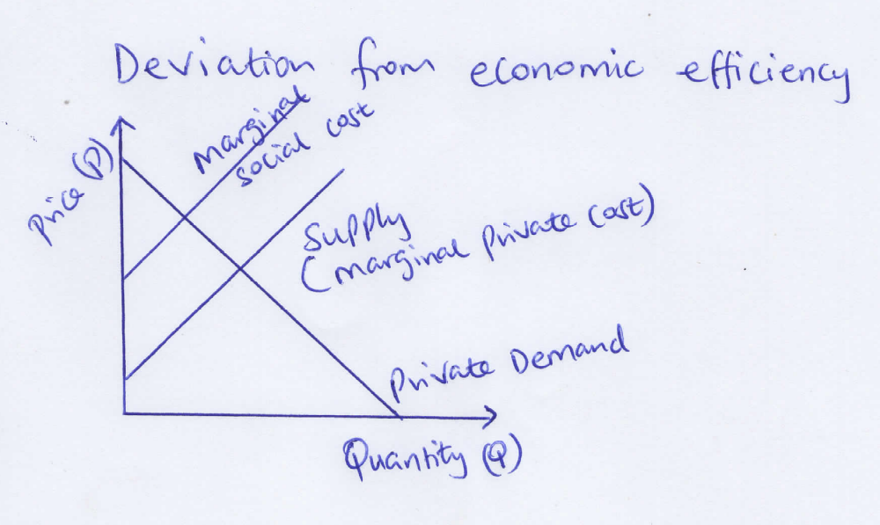

At a given quantity, the height of the demand curve measures the willingness to pay of the marginal buyer – the one who would leave the market if price was any higher. The supply curve reflects the cost of production. At any given quantity, the height of the supply curve is the cost of the marginal seller.
When there is no externality, the buyers and sellers who in our case are Ike restaurant owner and customers who take meals at Ike’s Bar-B-Q are the only ones whose welfare is affected by the equilibrium price and quantity. The total surplus equals consumer surplus plus producer surplus, and this measures the total benefit to society from the existence of Bar-B-Q facility. Now suppose the smoking law is enacted, there will be a certain amount of smoke emitted into the atmosphere for each unit of cigarette smoked. This smoke worsens the health of those who breathe the air, so it is a negative externality. Because of the externality, the cost to society of smoking is higher than the cost to the restaurant. We can draw the marginal cost to society curve above the marginal cost of the restaurant (supply) curve. If the cost to health due to the smoke is proportional to the amount of smoke in the atmosphere, the marginal social cost curve will be the marginal restaurants cost curve shifted vertically up. The marginal social cost at each quantity equals the marginal private cost to the restaurant plus the external cost to those who breathe the air.

